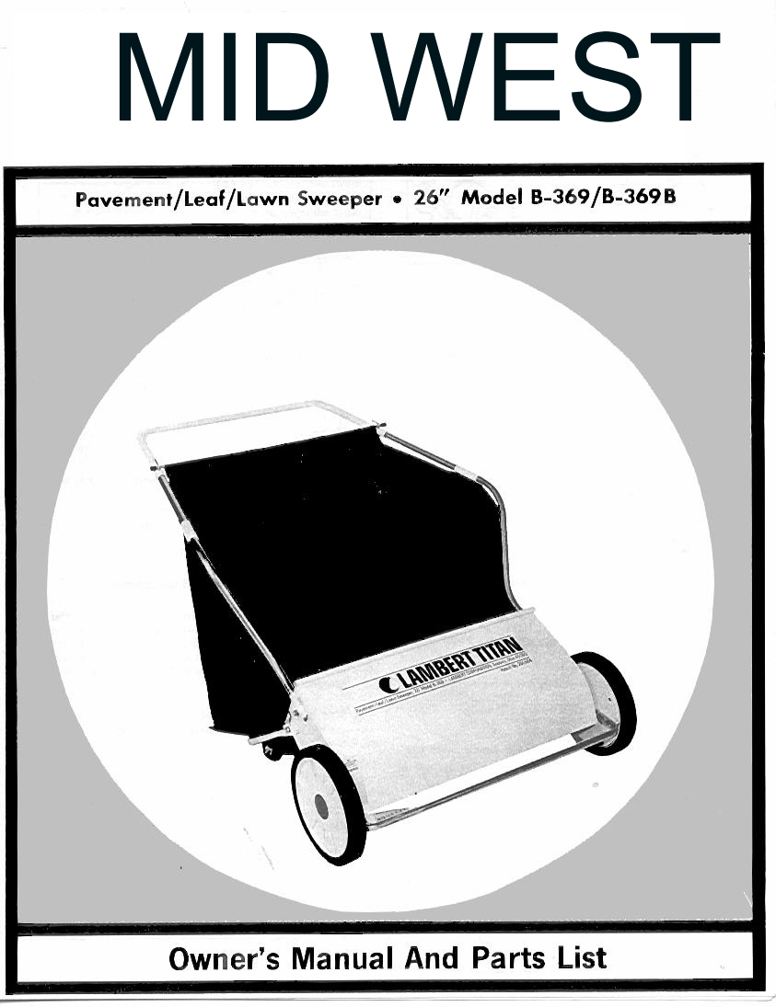
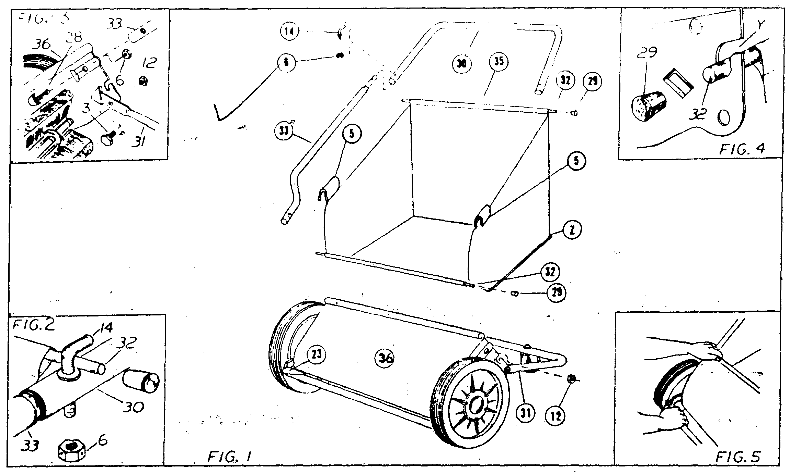
IMPORTANT: This sweeper was in perfect condition when it was shipped to you. If any damage is found when it is unpacked, save the carton and immediately request the delivering carrier to make an inspection report.

ASSEMBLY

- Only one adjustable wrench and pliers is required to as-semble your new lawnsweeper. Just lay all parts on a flat surface, have tools handy and follow these few simple instructions.  - Set chassis (36) on its wheels and swing support stand (31) to rear until ends of stand are against stops in chassis end plates. It is not necessary to loosen nuts (12). See figure 3.  - Slip reduced ends with holes of side handle tubes (33) into ends of steering handle tube (30). Line up hole in each end and insert hook bolt (14) through tubes. Secure with nuts (6). See figures (1 and 2) for correct position of all parts.  NOTE: Hold hook bolt with pliers when tightening nut with wrench. Make certain hook bolt points to rear of sweeper.  - Now, slip bottom ends of side handle tubes inside chassis. Make certain side tubes hit bottom stop of formed socket. Insert bolts (28) thru side handle tube (33) and chassis (36) and tighten nuts (6) securely. See figure 3. | - Hang hamper (34) inside handle assembly with rear hamper rod (32) in hooks (14). Place front hamper rod (32) in slots “Y” of chassis end plates. See figure 2 and 4. Fasten hangers (5) on side handles. Tilt hanger in—slide and twist out over tube. See figure 6. Make certain tape “Z” is outside hamper.  - FOR B-369B ONLY: Unroll baler (40) and place baler rod (32) in hooks (14) so baler will hang inside hamper. Now, allow baler to hang down back of hamper and across bottom of hamper. Then front baler rod (32) should be laid at front edge of hamper bottom panel.

All “right” and “left” directions should be considered as from your position behind the sweeper
OPERATION

- BRUSH HEIGHT ADJUSTMENT. You can sweep both lawn and paved areas by a simple adjustment of the brush. To raise brush to sweep your lawn, merely squeeze brush control and push down on front of bumper tube. At the same time, with the other hand, pull up on right corner of chassis. To lower brush, just reverse above instructions. See figure 5. Whenever sweeper seems to push hard, merely raise brush one notch higher. For best operation on lawns the brush should merely flick the top of grass blades.  - BALER. The baler allows you to almost double hamper capacity. Allow baler to hang down back and across bottom of hamper toward front of sweeper. Sweep until baler is full. Now, lift baler rod (32) up and to rear of hamper and hook on hook bolt (14). Sweep again until hamper is full.  - DUMPING SWEEPER. Release hamper hanger from side hamper tubes. Then, lift front hamper rod up and to rear of sweeper. Now, remove rear hamper rod from hooks (14) and lift hamper from sweeper. If dumping location is far from sweeping area, it may be desirable to pile several hamper loads of debris on a tarpaulin for faster removal to dumping location.  - STORAGE. Just fold stand forward under chassis. Hamper will fold itself when sweeper is hung on wall or set in corner against wall for compact winter storage.  - NO LUBRICATION REQUIRED. Brush axle bearings are lubricated and sealed during factory assembly. No other lubrication is necessary. DO NOT OIL OR GREASE GEARS IN WHEELS. If oil or grease is applied to these parts the brush will not rotate. Then it is necessary to re-move wheel and wipe parts clean. | - Your lawnsweeper is precision manufactured by experi-enced craftsmen, using the very finest in tools an ma- terials. Although it is ruggedly constructed, do not subject it to misuse. CAUTION: DO NOT PUSH SWEEPER TOO CLOSE TO FIRE – the brushes will burn. BE SURE TO WIPE OFF YOUR LAWNSWEEPER AFTER EACH USE. Store in a dry place out of direct sunlight. Don’t permit the sweeper to stand in the hot sun unless it is in actual use.  - You will find many work-saving uses for your lawn- sweeper. Use it in the early spring to give your lawn a good healthful scrubbing. Use it throughout the spring and summer both before and after mowing. Sweeping before mowing stands up the grass for a clean, even mowing – and protects your mower from sticks, stones, or nuts which might damage the blades of your mower. After mowing, your lawnsweeper will whisk away unsightly grass clip- pings – leaving your lawn velvety smooth.
INSTRUCTIONS FOR ORDERING PARTS
Minimum Parts Order Charge $20.00

- Address all parts orders or correspondence regarding customer service to your local dealer or:
Parts Dept.
Mid West Products, Inc.
P.O. Box 301 Or visit our WebSite at: www.LAMBERTmfg.com
Phillipsburg, OH 45354
Phone: 847.214.6261
- Write your name and address plainly (print or type).
- Explain where and how to ship.
- Give model number of unit.
- Give part number from parts list, as well as a description of the part and the quantity you need.
- Inspect all shipments you receive. If any parts are damaged or missing, file a claim with the carrier before accepting.
- If you are returning parts, be sure to include WITH THE SHIPMENT a list of the parts with your name and address.
- All orders for repair and replacement parts will be shipped when paid with MasterCard, Visa, or personal check/money order. Prices subject to change without notice.

MID WEST GUARANTEE
The merchandise you have purchased from us has been carefully engineered and manufactured under Lambert Products rigid quality standards and should give you satisfactory, dependable operation. However, like all mechanical merchandise, it may occasionally require adjustment or maintenance. Should you ever need technical assistance, please contact MID WEST PRODCTS, P.O. BOX 301, Phillipsburg, OH 45354

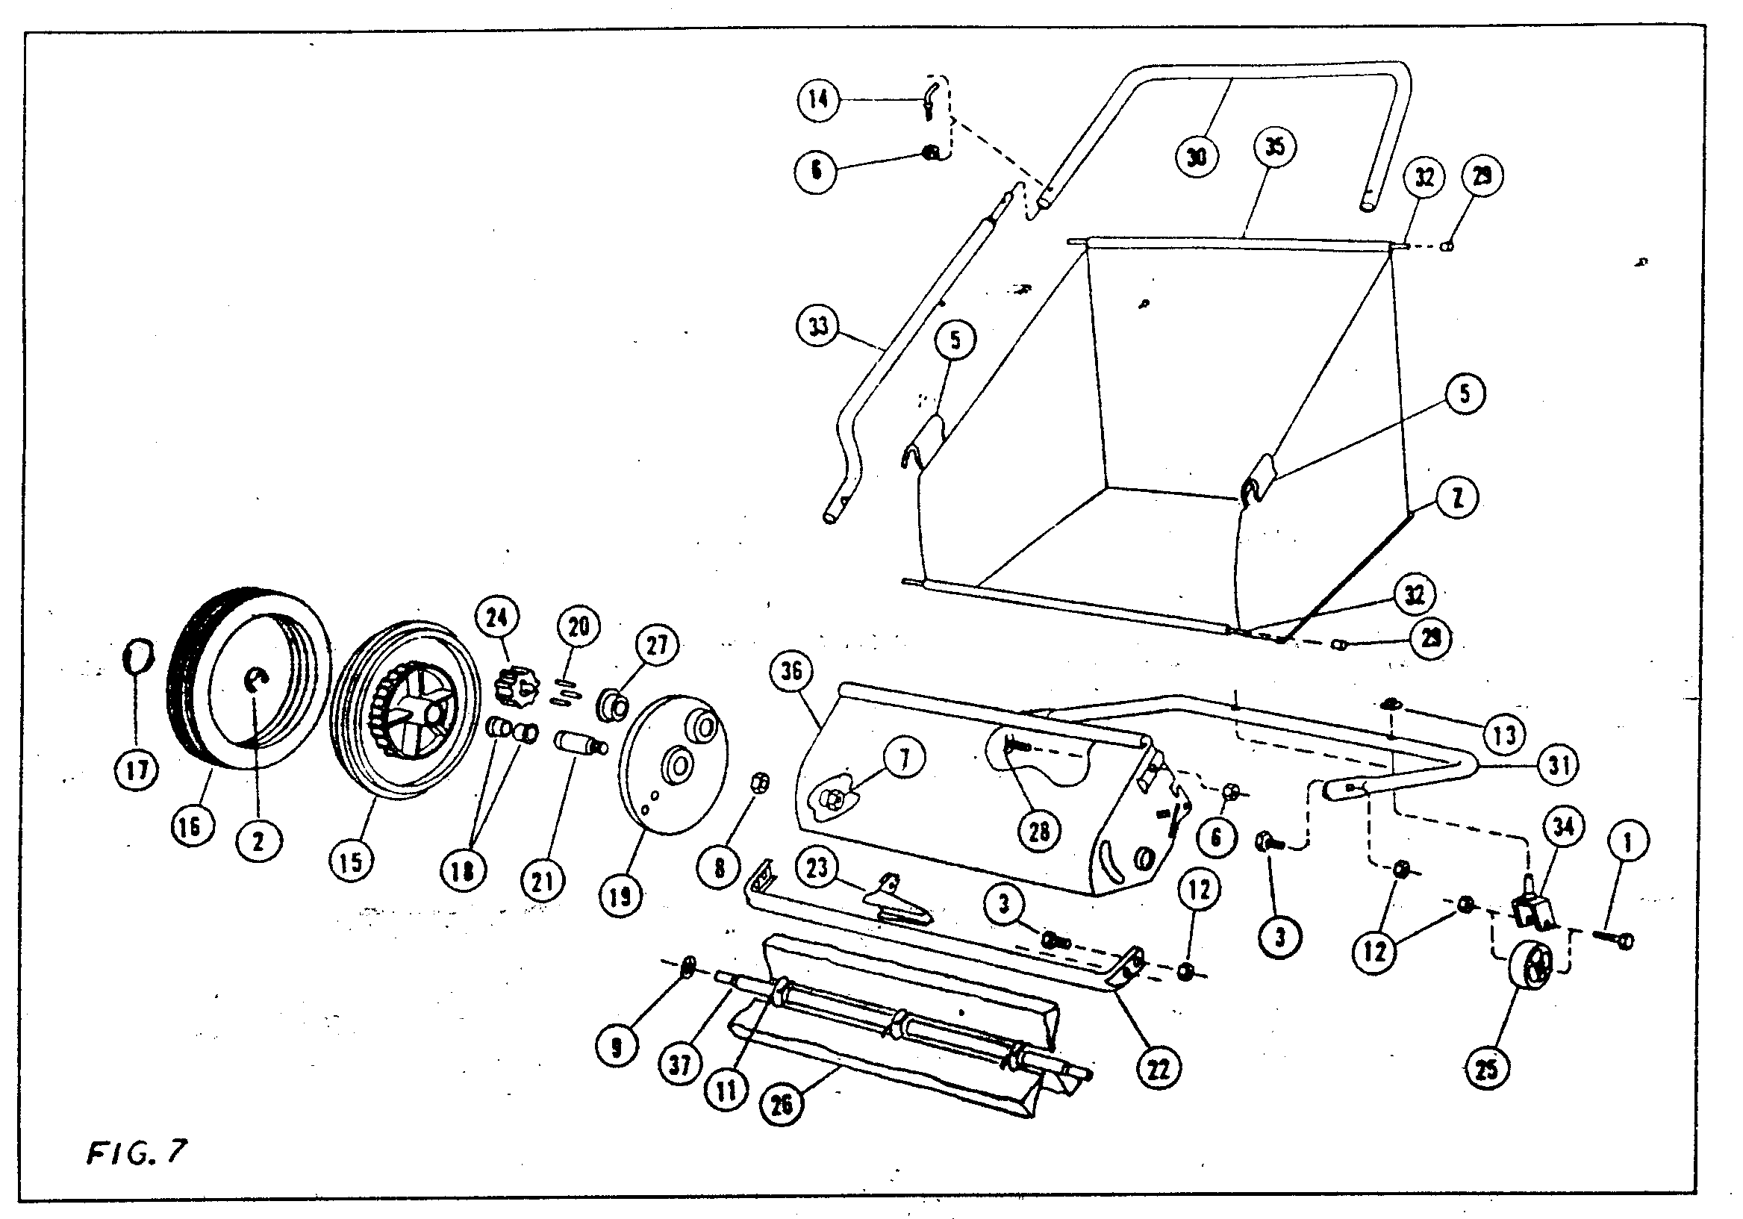

PARTS LIST

KEY | NUMBER | QTY |  |  | DESCRIPTION | KEY | PART NO. | QTY |  | DESCRIPTION
1 | L-127 | 2 |  |  | 5/16-18 X 1-1/2 HEX HD. CP. SC. | 22 | L-6102 | 1 |  | BUMPER TUBE
2 | L-262 | 2 |  |  | 5/8 TYPE "E" RETAINING RING | 23 | L-6151 | 1 |  | SPRING ADJUSTMENT
3 | L-279 | 6 |  |  | 5/16-18 X 1/2 HEX HD. SC. | 24 | L-6157 | 2 |  | PINION GEAR
6 | L-73 | 4 |  |  | 1/4-20 NUT | 25 | L-6190B | 2 |  | CASTER WHEEL
7 | L-5485 | 2 |  |  | 3/8-24 PILOT NUT | 26 | I-1060 | 3 |  | BRUSH STRIP
8 | L-5486M | 2 |  |  | 3/8-24 LOCK NUT (SPEC.) | 27 | I-1080 | 2 |  | FLANGE BEARING
9 | X-1041 | 2 |  |  | 1/2 PUSH ON | 28 | X-1182 | 2 |  | 1/4-20 X 1-1/4 BOLT
11 | X-1043 | 9 |  |  | BRUSH HOLDER SPRING | 29 | I-1287 | 4 |  | RUBBER CAP
12 | X-1107 | 8 |  |  | 5/16-18 CENTER LOCK NUT | 30 | I-1354 | 1 |  | STEERING HANDLE
13 | X-1348 | 2 |  |  | 5/16" PUSH ON CAP | 31 | I-1336 | 1 |  | CARRIAGE TUBE
14 | X-1360 | 2 |  |  | HOOK BOLT | 32 | I-1344 | 2 |  | HAMPER ROD
15 | L-5464 | 2 |  |  | 10" PLASTIC WHEEL | 33 | I-2274 | 1 |  | SIDE HANDLE TUBE R.H.
16 | I-1418 | 2 |  |  | TIRE | NI | I-2275 | 1 |  | SIDE HANDLE TUBE L.H.
17 | L-5471B | 2 |  |  | HUB CAP | 34 | IA-1311 | 2 |  | CASTER BRACKET ASSEMBLY
18 | L-5472 | 4 |  |  | WHEEL BUSHING | 35 | IA-1815 | 1 |  | HAMPER ASSEMBLY
19 | I-2399 | 2 |  |  | WHEEL SHIELD | 36 | IA-2277 | 1 |  | SHIELD ASSEMBLY
20 | L-5480 | 6 |  |  | PINION PAWL | 37 | IA-1346 | 1 |  | BRUSH AXLE & DISC ASSEMBLY
21 | L-5496 | 2 |  |  | WHEEL STUD AXLE

