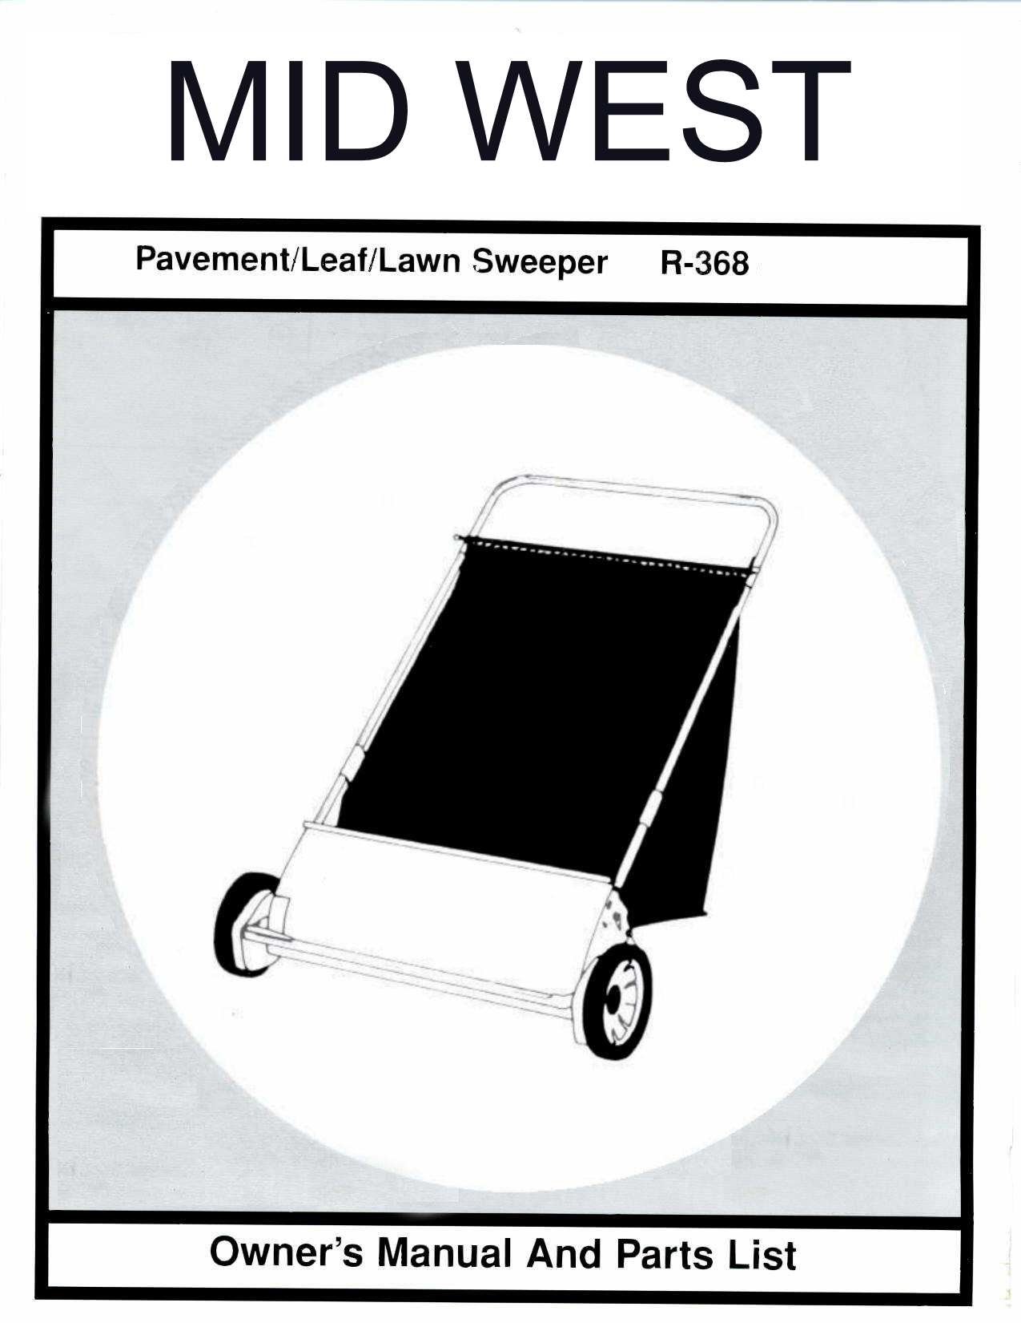
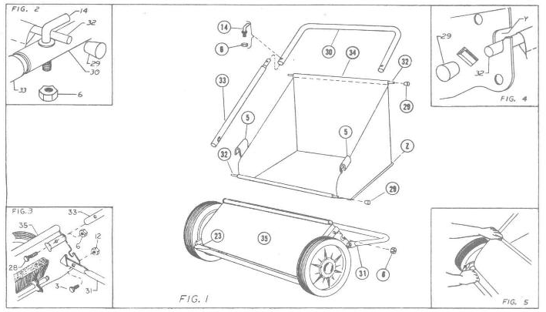

IMPORTANT: This sweeper was in perfect condition when it was shipped to you. If any damage is found when
it is unpacked, save the carton and immediately request the delivering carrier to make an inspection report.

ASSEMBLY

All “right” and “left” directions should be considered as from your position behind the sweeper

- Only one adjustable wrench and pliers is required to assemble your new lawnsweeper. Just lay all parts on a flat surface, have tools handy and follow these few simple instructions.  - Set chassis (35) on it’s wheels and swing support stand (31) to rear until ends of stand are against stops in chassis end plates. It is not necessary to loosen nuts (12). See figure 3.  - Slip reduced ends with holes of side handle tubes (33) into ends of steering handle tube (30). Line up hole in each end and insert hook bolt (14) through tubes. Secure with nuts (6). See figures (1 and 2) for correct position of all parts.  NOTE: Hold hook bolt with pliers when tightening nut with wrench. Make certain hook bolt points to rear of sweeper.  - Now, slip bottom ends of side handle tubes inside chassis. Make certain side tubes hit bottom stop of formed socket. Insert bolts (28) thru side handle tube (33) and chassis (35) and tighten nuts (6) securely. See figure 3. | - Hang hamper (34) inside handle assembly with rear hamper rod (32) in hooks (14). Place front hamper rod (32) in slots “Y” of chassis end plates. See figure 2 and 4. Fasten hangers (5) on side handles. Tilt hanger in—slide and twist out over tube. See figure 6. Make certain tape “Z” is outside hamper.

OPERATION
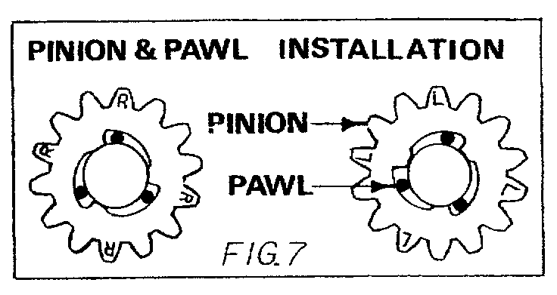
- BRUSH HEIGHT ADJUSTMENT. You can sweep both
lawn and paved areas by a simple adjustment of the brush.
To raise brush to sweep your lawn, merely squeeze brush control and push down on the front bumper tube. At the same time, with the other hand, pull p on the right corner of chassis. To lower brush, just reverse above instructions. See figure5. Whenever sweeper seems to push hard, merely raise brush one notch higher. For best operation on lawns the brush should merely flick the top of grass blades.

- DUMPING SWEEPER. Release hamper hanger (5) from side hamper tubes. Then, lift front hamper rod up and to rear of sweeper. Now, remove rear hamper rod from hooks (14) and lift hamper from sweeper. If dumping location is far from sweeping are, it may be desirable to pile several hamper loads of debris on a tarpaulin for faster removal to dumping location.

- STORAGE. Just fold stand forward under chassis. Hamper will fold itself when sweeper is hung on wall or set in corner against wall for compact winter storage.

- NO LUBRICATION REQUIRED. Brush axle bearings are lubricated and sealed during factory assembly. No other lubrication Is necessary. DO NOT OIL OR GREASE GEARS IN WHEELS. If oil or grease is applied to these parts the brush will not rotate. It will then be necessary to remove wheel and wipe all parts clean.

- When servicing or replacing the pinion or pawl pins please refer to the pinion and pawl installation figure 7. Right (R) and Left (L) notations on the pinion gears are from your position behind the lawnsweeper.

- Your lawnsweeper is precision manufactured by experienced craftsmen, using the very finest in tools and materials. Although it is ruggedly constructed, do not subject it to misuse. CAUTION: DO NOT PUSH SWEEPER TOO CLOSE TO FIRE WHEN BURNING LEAVES—the brushes will burn. BE SURE TO WIPE OFF YOUR LAWNSWEEPER AFTER EACH USE. Store in a dry place out of direct sunlight. Don’t permit the sweeper to stand in hot sun unless it is in actual use

You will find many work-saving uses for your lawnsweeper. Use it in the early spring to give your lawn a good healthful scrubbing. Use it throughout the spring and summer both before and after mowing. Sweeping before mowing stands up the grass for a clean, even mowing – and protects your mower from sticks, stones or nuts which might damage the blades of your mower. After mowing, your lawnsweeper will whisk away unsightly grass clippings – leaving your lawn velvety smooth.

INSTRUCTIONS FOR ORDERING PARTS

INSTRUCTIONS FOR ORDERING PARTS
NOTE: Minimum Parts Order Charge $20.00
- Address all parts order or correspondence regarding service to your local dealer or:

Parts Department
Mid West Products, Inc.
P.O. Box 301
Phillipsburg, OH 45354

Phone: 937-337-3641
- Write your name and address plainly (print or type)
- Explain where and how to ship.
- Give model number of unit.
- Give part number from parts list, as well as a description of the part and the quantity you need.
- Inspect all shipments you receive. If any parts are missing, file a claim with the carrier before accepting.
- If you are returning parts, be sure to include WITH THE SHIPMENT a list of the parts with your name and address.
- All orders for repair and replacement parts will be shipped when paid with MasterCard, Visa, Discover, or personal check/Money Order. Prices Subject to change without notice.

GUARANTEE
The merchandise you have purchased from us has been carefully engineered and manufactured under Lambert Products rigid quality standards and should give you satisfactory, dependable operation. However, like all mechanical merchandise, it may occasionally require adjustment or maintenance. Should you ever need technical assistance, please contact MID WEST PRODCTS, P.O. BOX 301, Phillipsburg, OH 45354

MID WESTPRODUCTS, INC
P.O. Box 301 * Phillipsburg , OH 45354
Phone: 847.214.6261 * Fax: 847.756.3831

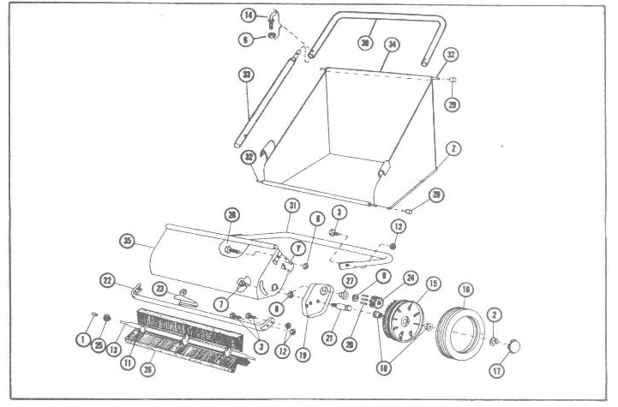

PARTS LIST

 |  | QTY
KEY | NUMBER | 20" | 26" |  | DESCRIPTION
1 | X-1040 | 2 | 2 |  | Spiral Pin
2 | L-262 | 2 | 2 |  | 5/8 Ret. Ring
3 | L-279 | 6 | 6 |  | 5/16-18 x 1/2 Hex Head Sc.
6 | L-73 | 4 | 4 |  | 1/4-20 HEX Nut
7 | L-5484 | 2 | 2 |  | 3/8-24 Pilot Nut
8 | L-5486M | 2 | 2 |  | 3/8-24 Lock Nut
9 | X-1041 | 2 | 2 |  | 1/2" Push-on
11 | X-1043 | 9 | 9 |  | Brush Spring
12 | X-1107 | 6 | 6 |  | 5/16-18 Lock Nut
13 | 1A-1346 | - | 1 |  | Axle Assembly
13 | 1A-1422 | 1 | - |  | Axle Assembly
14 | X-1360 | 2 | 2 |  | Hook Boot
15 | 1-1004 | 2 | 2 |  | Plastic Wheel
16 | 1-1014 | 2 | 2 |  | Tire
17 | L-5471B | 2 | 2 |  | Hub Cap
18 | L-5472 | 4 | 4 |  | Bushing
19 | 1-1005L | 1 | 1 |  | Adjusting Plate L.H.
N.I. | 1-1005R | 1 | 1 |  | Adjusting Plate R.H.
20 | L-5480 | 6 | 6 |  | Pinion Pawl
21 | L-5496 | 2 | 2 |  | Wheel Stud
22 | L-6102 | - | 1 |  | Bumper Tube
22 | 1-1011 | 1 | - |  | Bumper Tube
 |  | QTY
KEY | NUMBER | 20" | 26" |  | DESCRIPTION
23 | L-6151 | 1 | 1 |  | Spring Adjustment
24 | L-6157 | 2 | 2 |  | Pinion Gear
25 | 1-1000 | 2 | 2 |  | Shaft End Plug
26 | 1-1060 | - | 3 |  | Brush Strip
26 | 1-1949 | 3 | - |  | Brush Strip
27 | 1-1288 | 2 | 2 |  | Axle Bearing
28 | X-1182 | 2 | 2 |  | 1/4-20 x 1-1/4 H.H.C.S.
29 | 1-1287 | 4 | 4 |  | Rubber Cap
30 | 1-1358 | - | 1 |  | Steering Handle
30 | 1-1923 | 1 | - |  | Steering Handle
31 | 1-1335 | - | 1 |  | Carriage Tube
31 | 1-1361 | 1 | - |  | Carriage Tube
32 | 1-1344 | - | 2 |  | Hamper Rod
32 | 1-1950 | 2 | - |  | Hamper Rod
33 | 1-2256 | 2 | 2 |  | Side Handle Tube
34 | 1A-1813 | - | 1 |  | Hamper Assembly
34 | 1A-1952 | 1 | - |  | Hamper Assembly
35 | 1A-2257 | - | 1 |  | Shield Assembly
35 | 1A-2258 | 1 | - |  | Shield Assembly
N.I. | 1-2266 | 1 | 1 |  | Hi-Lo Decal
N.I. | Furnished not illustrated

P.O. BOX 301, ANSONIA, OH 45354
PHONE: 847.214.6261 FAX: 847.756.3831
Website: www.LAMBERTmfg.com
E-Mail: Parts@LAMBERTmfg.com

MID WEST
PRODUCTS, INC.

